Effects of methane concentration on the performance and emissions of a small CI engine run on dual-fuel (diesel-biogas)
H Ambarita^{1,2 *}, E P Sinulingga¹, and M KM Nasution³
¹Klinik Publikasi Ilmiah (KPI) University of Sumatera Utara, Jl. dr. Mansur Kampus USU Medan 20155
²Sustainable Energy Research Centre, Faculty of Engineering University of Sumatera Utara, Jl. Almamater Kampus USU Medan 20155
³Vice Rector for Research & Community Service and Collaboration of University of Sumatera Utara, Jl. dr. Mansur Kampus USU Medan 20155

*Email: himsar@usu.ac.id
Abstract. In this paper a small Compression Ignite (CI) is tested by fuelling it on dual-fuel (diesel-biogas) mode. The objective is to explore the effects of methane concentration of the biogas on the performance and emissions characteristics of the CI engine. A four stroke single cylinder and naturally air cooled CI engine, typically used for small tractor, is used in the experiments. The cylinder diameter, bore, and maximum output are 75 mm, 80 mm, and 4.89 kW, respectively. The CI engine is coupled with generator to generate electricity. Two type of biogas are used, the first is biogas with 60% methane concentration and the second one is 70%. The loads and engine speed are varied from 1000 rpm to 1500 rpm. The results show that output power of the CI run on dual-fuel mode is higher than the engine run on pure diesel. However, the efficiency on duel-fuel is lower and specific fuel consumption is higher in comparison with the engine run on pure-diesel. There are no specific effects of increasing methane concentration on the performance and the emissions. These facts suggest that it is better to operate the CI engine in dual fuel mode with raw biogas.
- Introduction
In order to avoid the world from the Global Warming, many countries have committed on reducing their Green Houses Gases (GHGs) emissions. The Government of Indonesia (GoI) has released its target on reducing GHG emissions by 26% from level business as usual (BAU) by 2020 and it can be increased up to 41% by international aids [1]. Energy is one of the biggest sectors that contribute to Indonesia GHGs emissions [2]. This includes activities that burn fossil fuel in engines in order to produce power. In Indonesia, the main consumption of fossil fuel is diesel oil which is used in Compression Ignition (CI) engines [3]. The CI engines are mainly used in heavy machineries such truck, agricultural engines, marine, and power plants. Thus reducing diesel consumption will reduce GHGs emissions. On the other hand, in Indonesia fossil fuel (gasoline, diesel, kerosene) is still subsidized and it becomes a load for government budget. These facts suggest that reducing diesel oil consumption in CI engines will give a significant impact on mitigation GHG emissions and it will help the GoI in reducing fossil fuel subsidy. One of the potential solutions for reducing fuel consumption in CI engine is dual-fuel system.
Several studies on CI engine run on dual-fuel mode have been found in literature. Bedoya et al [4] reported a study on the effect of mixing system and pilot fuel quality on diesel-biogas dual-fuel engine performance. The simulated biogas (60% CH₄-40%CO₂) as primary fuel, and diesel and palm oil biodiesel as pilot fuel. Cacua et al [5] studied experimentally the effects of oxygen enriched air on the operation and performance of a diesel-biogas dual-fuel engine. The biogas composition was 60% CH₄ - 40% CO₂ and the oxygen concentration in the intake air engine was varied from 21 to 27% O₂. Tippayong et al [6] carried out a study on electricity production for on-farm using a small CI dual-fuel diesel-biogas. The main objective was to evaluate the effect of long-term operation on performance and wear of the dual-fuel engine. The composition of the biogas was 65.6% CH₄ and 26.4% CO₂. The CI engine was tested for 2000 hours of operation. The dual-fuel engine appeared to perform well and have great potential for use on-farm energy utilization. Makareviciene et al [7] explored the impacts of CH₄ compositions in a big CI four stoke and four-cylinders engine when operated under dual-fuel biogas-diesel mode. The composition of CH₄ in biogas varied from 65%, 85%, and 95%. The impact of exhaust gas recirculation (EGR) was also explored. Tonkunya and Wongwuttanasatian [8] reported a study on the utilization of biogas-diesel mixture as fuel in a fertilizer pelletizing machine for reduction of GHG emission in small farms. In the experiment the rated power of the CI engine and the composition of the biogas were not reported. The results showed that by using biogas as dual-fuel mode in the CI engine, a reduction in diesel fuel of 63% was achieved. This result was equivalent to 13 ton CO₂eq/year/farm in Thailand case. Nathan et al [9] performed an experimental study on the biogas-biodiesel HCCI mode of engine operation. The objective was to investigate the potential of the HCCI concept to utilize biogas effectively.
The above literatures show that study on CI engine run on dual-fuel mode has come under scrutiny in order to decrease the fossil fuel. Several modifications or parameters have been proposed such as the effects of mixing system, oxygen enrichment of the inlet air, compression ratio, long-term operation, etc. To the best knowledge of the authors, there is no study on the effects of the methane enrich biogas on the small CI engine run on dual-fuel mode found in literature. Here, a small Compression Ignite (CI) is tested by fueling it on dual-fuel (diesel-biogas) mode. The objective is to explore the effects of methane concentration in the biogas on the performance and emissions characteristics of the CI engine. The results are expected to supply the necessary information for the Government of Indonesia in development alternative solutions for reducing diesel oil consumption.
Catatan: Paragraph pertama tidak menggunakan spasi tetapi paragraph kedua dst mempunyai spasi yang sedikit menjorok ke dalam. Kemudian mengutip referensi menggunakan angka [1].

- Method
In this study a CI engine which is originally used in a small tractor for agricultural will be used as a tested engine. The specifications of the CI engine are presented in Table 1. It is a single-cylinder four stroke CI engine fueled by diesel oil. This engine has a maximum output power of 4.86 W. It is a small engine with a weight of 60 kg and typically found in Indonesian small farmer.

Table 1. Specification of the CI engine
No | Parameter | Value
1 | Commercial name/model | Tiger Diesel Engine R175 AN
2 | Number of cylinder/stroke | Single-cylinder/4 strokes and Horizontal
3 | Cooling system | Air cooled
4 | Bore Stroke | 75 mm 80 mm
5 | Maximum output | 4.86 kW
6 | Rated output | 4.41 kW
7 | Rated speed | 2600 rpm
8 | Engine weight | 60 kg
9 | Commercial name/model | Tiger Diesel Engine R175 AN

Catatan: Tabel selalu berada di tengah kolom dan tidak menggunakan garis vertical. Nama table di atas deberi titik dan bold. Huruf yang digunakan adalah 11, tetapi jika isi tabel terlalu padat hurufnya dapat diperkecil.

Experimental apparatus
In order to perform the study, an experimental apparatus has been designed and developed as shown in Figure 1. It consists of a unit of CI engine, generator, series of lamps, biogas tank, gas mixer, and measurements apparatus. In single fuel mode (pure diesel oil only) the CI engine will be tested without modification. In dual-fuel mode, a gas mixer has been designed and developed in order to mix the fresh air with biogas. The mixture of the fresh air and biogas will be injected into the CI engine. To simulate the load, the CI engine will be coupled with a single phase synchronous generator using pulley.

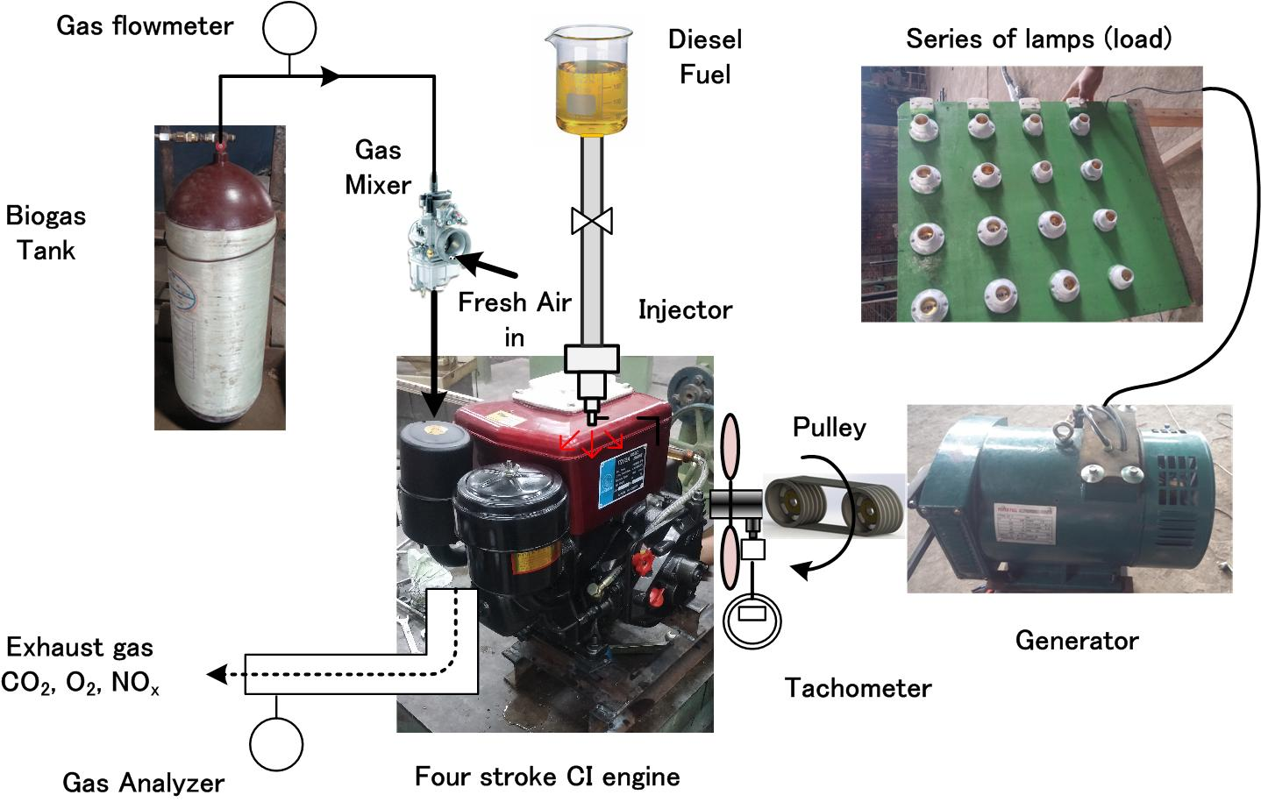

Figure 1. Experimental apparatus

Catatan: Gambar dibuat ditengah halaman dan caption gambar ditulis (Figure 1.) atau jangan disingkat jadi “Fig 1”.

Problem formulation
In order to perform the analysis, several parameters are used and formulated here. The objective of introducing biogas into the engine is to reduce the diesel mass flow rate in comparison with single diesel mode. In order to present the percentage of diesel fuel replaced by the biogas, the replacement ratio [] is calculated by
(1)
where (kg/s) is the diesel mass flow rate in diesel mode and (kg/s) is the diesel mass flow rate in dual-fuel mode.
Catatan: Persamaan ditempatkan di tengah baris dan diberi nomor seperti “(1)”.

- Results and Discussions
The results will be discussed in 5 subsections, they are output power, total efficiency, specific fuel consumption, exhaust gas emissions, and diesel replacement ratio

Output power
Here, the output power is defined as the electric power resulted by the generator. The voltage and the current are measured and the electric power is calculated using equation (1). The electric power as a function of engine rotation speed is shown in Figure 2. The load is fixed at 1500 W. The figure shows that for all cases the output power increases as the engine speed increases. The output power of the CI engine run on dual-fuel is slightly higher than pure diesel at the same speed. The results from other loads show the same trend. It can be said that CI engine can be run on dual-fuel mode perfectly and shows a better output power in comparison with pure diesel.

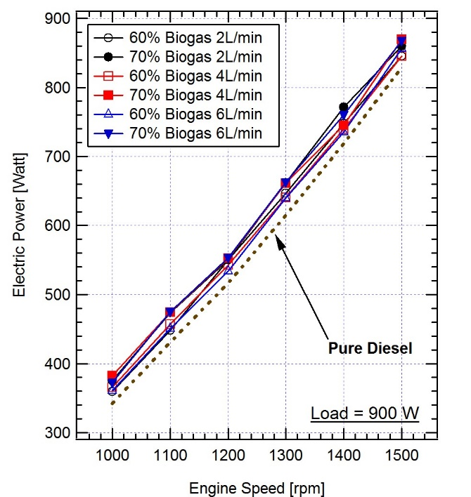  (a) | 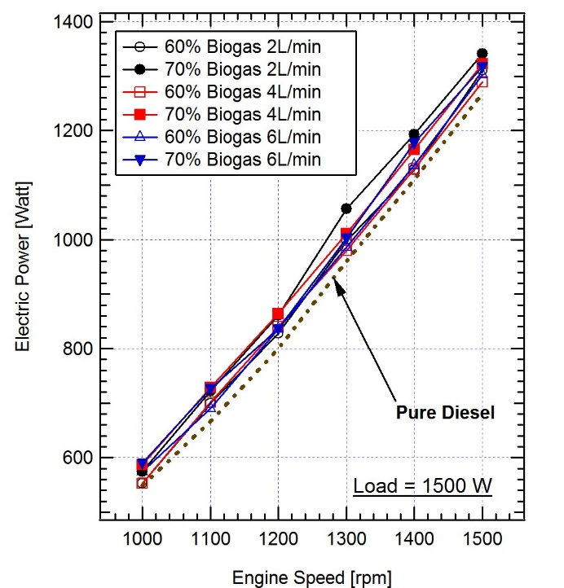  (b)

Figure 2. Output power of the CI engine at (a) load 900 W and at (b) load 1500 W

Total efficiency
Lanjutkan di sini

Specific fuel consumption (scf)
Lanjutkan di sini

Exhaust gas emission
Lanjutkan di sini

- Conclusions
Lanjutkan di sini

Acknowledgments
The authors gratefully acknowledge that the present research is supported by Ministry of Research and Technology and Higher Education Republic of Indonesia. The support is under the research grant BP-PTN USU of Year 2016 Contract Number XXX/XXX.
References
- Ambarita H 2016 Case studies in Thermal Engineering 7 36-46.
- Government of Indonesia Presidential Decree No No 61 Year 2011, National Action Plan For Reducing Greenhouse Gas Emissions.
- Minister of Energy and Mineral Resources, 2011, Handbook of Energy and Economic Statistics of Indonesia, 2011.
- Hutapea M 2012 Reviewing opportunities for bio-energy and waste to energy development in Indonesia, Ministry of Energy and Minereal Resoruces of Indonesia.
- Bedoya ID, Saxena S, Cadavid FJ, Dibble RW, Wissink M 2012 Applied Energy 618-629.
- Cacua K, Amell A, Cadavid F 2012 Biomass and Bioenergy 45 (2) 159-167.
- Tippayawong N, Promwungkwa P, Rerkkriangkrai 2007 Biosystem Engineering 98 26-32.
- Makareviciene V, Sendzikiene E., Pukalskas S, Rimkus A, Vegneris R 2013 Energy Conversion and Management 75 224 – 233.
- Tonkunya N, Wongwuttanasatian T 2013 Energy for Sustainable Development 17 240 – 244.
- Nathan SS, Mallikarjuna JM, Ramesh A 2010 Energy Conversion and Management 51 1347 – 1353.

